St. Ambrose Parking Lot Addition, Albany NY

Laberge Group was pleased to assist St. Ambrose in Albany, NY with the design and construction of an addition to their parking lot. The design incorporates a bioretention stormwater filtering system which consists of raised berms and a landscaped depression that will collect stormwater runoff from the parking lot extension and utilize plantings, mulch, and soil to filter the stormwater discharge from the parking lot addition. Bioretention practices such as the one deployed in this project prevent bacteria, heavy metals, and other pollutants typically found in stormwater runoff from entering local waterways and contaminating surface and groundwater resources. Laberge Group also conducted Stormwater Pollution Prevention Plan (SWPPP) inspections during construction.

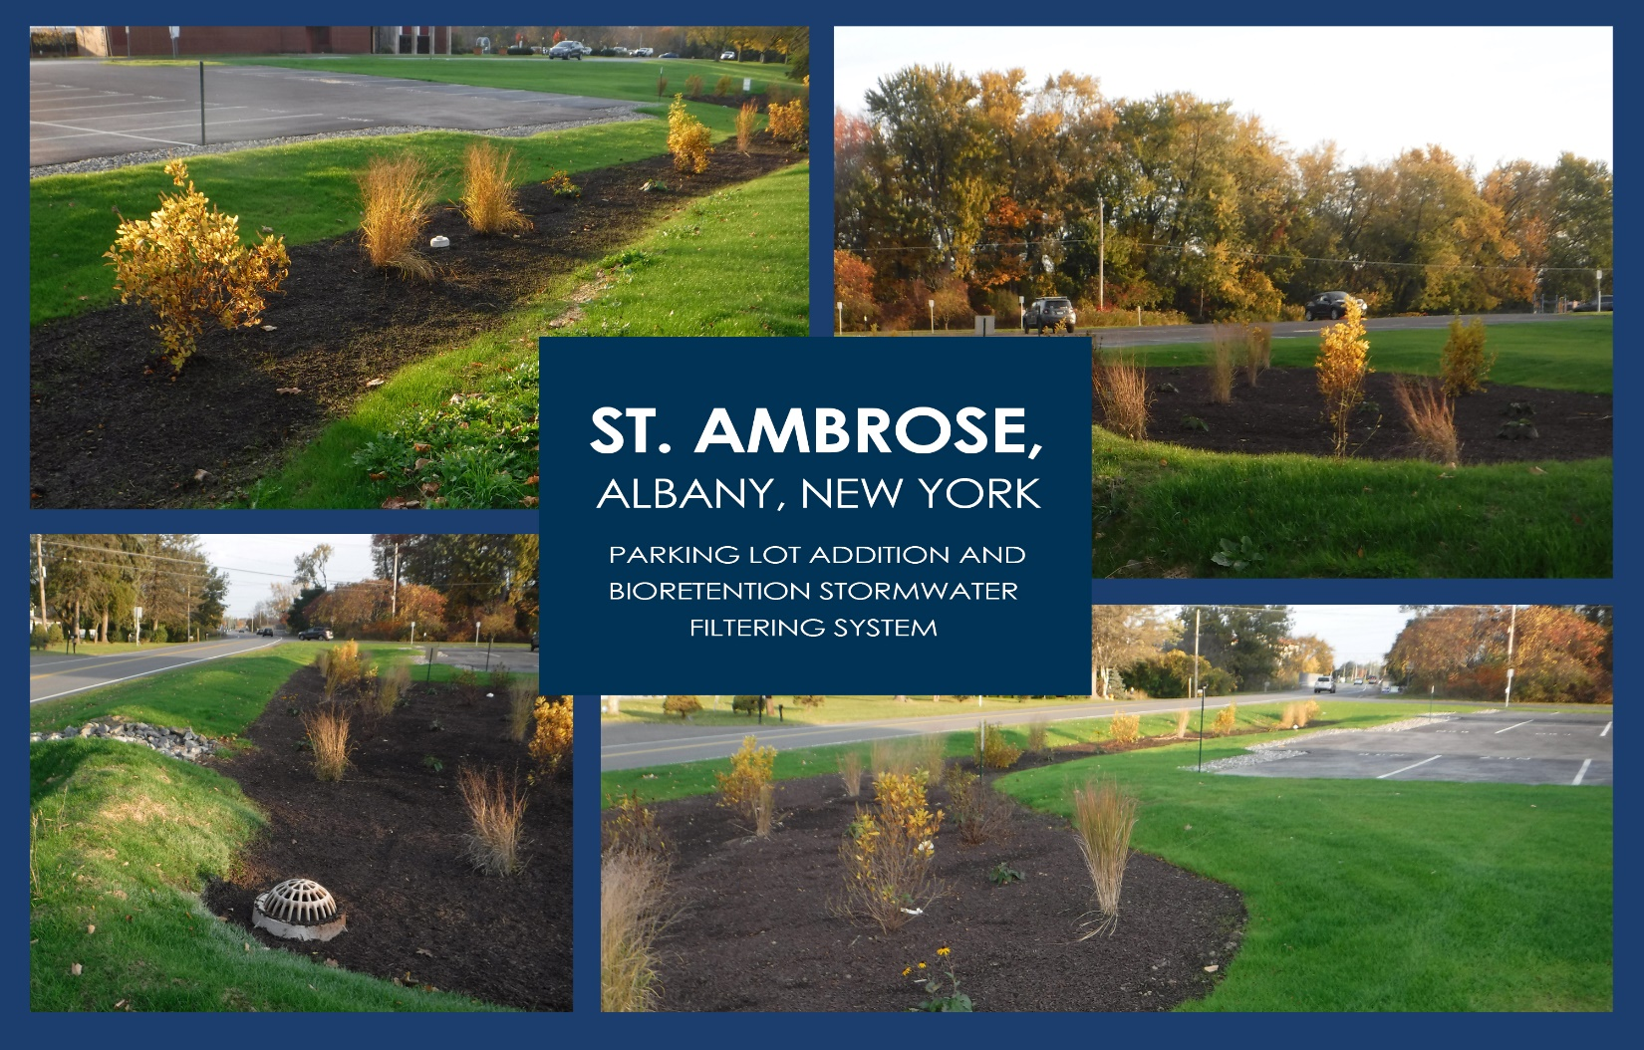

PEK: __X__ 1/5/24

BHS: ____